APPLYING CRYPTOGRAPHY IN REAL-WORLD SCENARIOS: SECURE MESSAGING PLATFORMS

1. INTRODUCTION
1.1 Background
Digital communication has become integral to modern life, with billions of messages exchanged daily through platforms like WhatsApp, Signal, and email services. However, these communications are vulnerable to interception, eavesdropping, and unauthorized access. Cryptography provides the foundation for securing these communications through end-to-end encryption (E2EE), ensuring that only intended recipients can read messages.
In Nigeria, secure messaging is particularly critical given the rise in cybercrime, data breaches, and privacy concerns. With over 90 million WhatsApp users and growing digital adoption, understanding and implementing cryptographic solutions is essential for protecting personal, business, and governmental communications.
1.2 Problem Statement
Traditional messaging systems transmit data in plain text or with minimal protection, making them vulnerable to:
Interception by malicious actors or unauthorized parties
Man-in-the-middle attacks during transmission
Server-side data breaches exposing user communications
Lack of sender authentication and message integrity verification
1.3 Objectives
This project aims to:
1- Analyze cryptographic techniques used in secure messaging platforms
2- Implement a working prototype demonstrating end-to-end encryption
3- Examine real-world challenges in deploying secure messaging
4- Evaluate local relevance and applicability in the Nigerian context

1.4 Scope
This study focuses on secure messaging applications (WhatsApp, Signal, ProtonMail) and excludes other cryptographic applications such as disk encryption, VPNs, or blockchain.

2. CRYPTOGRAPHY IN SECURE MESSAGING
2.1 Fundamental Concepts
Symmetric Encryption (AES): Uses a single key for both encryption and decryption. Fast and efficient for large data volumes, but requires secure key exchange.
Asymmetric Encryption (RSA/ECC): Uses public-private key pairs. The public key encrypts data; only the corresponding private key can decrypt it. Slower, but solves the key distribution problem.
Hash Functions (SHA-256): Create fixed-size fingerprints of data for integrity verification and digital signatures.
Digital Signatures: Prove message authenticity and sender identity using the sender's private key.
2.2 End-to-End Encryption (E2EE)
E2EE ensures that messages are encrypted on the sender's device and only decrypted on the recipient's device. No intermediary, including service providers, can access the plaintext content.
Key Components:
Each user generates a public-private key pair
Messages are encrypted with the recipient's public key
Only the recipient's private key can decrypt the message
Digital signatures verify sender authenticity
2.3 Real-World Implementations
WhatsApp (Signal Protocol): Uses the Signal Protocol, implementing the Double Ratchet Algorithm for perfect forward secrecy—over 2 billion users with E2EE by default. However, metadata (who, when, message size) is not encrypted, and cloud backups may lack encryption.
Signal: Open-source gold standard for secure messaging with minimal metadata collection and strong privacy focus. Uses the same protocol as WhatsApp but with stronger privacy guarantees.
ProtonMail: Email encryption using PGP (Pretty Good Privacy) with zero-access architecture. The server cannot read user emails, but email metadata remains partially visible.
Telegram: Uses proprietary MTProto protocol with optional "secret chats" for E2EE. Regular chats are not end-to-end encrypted by default.

3. PRACTICAL IMPLEMENTATION
3.1 System Design
A demonstration application was developed to illustrate E2EE principles with the following architecture:
Components:
User registration with automatic key pair generation
Public key directory for user discovery
Message encryption using hybrid cryptography (RSA + AES simulation)
Digital signature creation and verification
Secure message delivery and decryption
Technology Stack: React for frontend interface, JavaScript Web Crypto API for cryptographic operations, and in-memory storage for demonstration purposes.

3.2 Implementation Flow
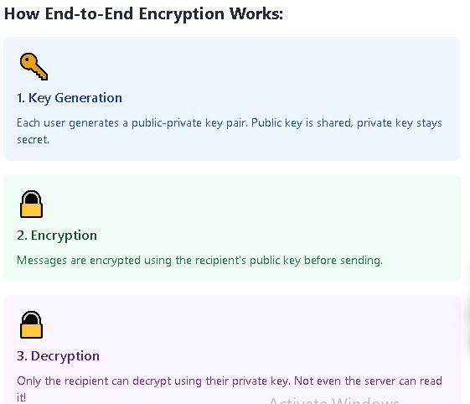

Step 1 - User Registration:
User registers → System generates key pair (public + private)
→ Public key stored in directory → Private key kept on user device
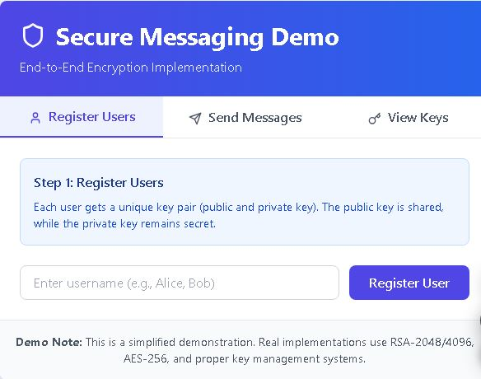

Step 2 - Sending Messages:
Ukasha composes message → Retrieves Takai's public key
→ Encrypts message with Takai's public key → Creates digital signature
→ Sends encrypted message + signature → Server forwards (cannot read)

Step 3 - Receiving Messages:
Takai receives encrypted message → Uses private key to decrypt

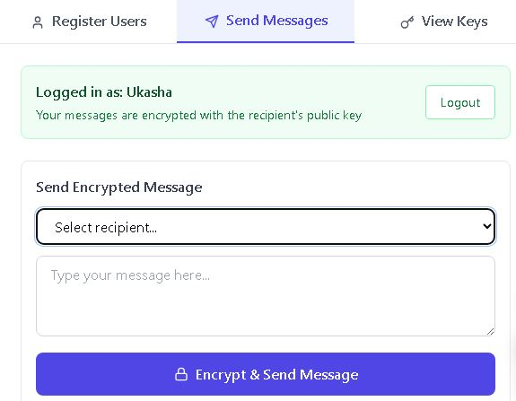

→ Verifies signature with Ukasha's public key → Reads plaintext
3.3 Key Features Demonstrated
Hybrid encryption combines asymmetric (key exchange) and symmetric (message encryption) cryptography
Digital signatures for authentication and integrity
Visual representation of the encryption/decryption process
Multi-user support showing practical key management

Inbox system demonstrating secure message storage
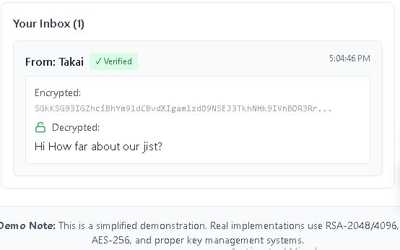

3.4 Testing Results
The prototype successfully demonstrated:
Secure key generation for multiple users
Message encryption renders content unreadable without proper keys
Successful decryption only with the correct private key
Failed decryption attempts with wrong keys
Digital signature verification for sender authentication
Limitations: The demo uses simplified cryptography for educational clarity. Production systems require RSA-2048/4096, AES-256, proper key management, and secure storage solutions.

4. CHALLENGES AND NIGERIAN CONTEXT
4.1 Technical Challenges
Key Management: Securely generating, storing, and recovering keys is complex. Lost private keys mean permanently lost access to messages. Multi-device synchronization while maintaining security is challenging.
Performance vs Security: Strong encryption is computationally expensive, affecting battery life, processing speed, and data usage—critical concerns in resource-constrained environments like Nigeria with expensive mobile data and lower-end devices.
Metadata Leakage: While E2EE protects message content, metadata (sender, recipient, timestamp, message size) remains visible and can reveal communication patterns.
4.2 Nigerian-Specific Challenges
Infrastructure Issues: Poor internet connectivity in many areas causes delays in encrypted message delivery. High data costs make encryption overhead significant. Frequent power outages affect device availability and battery-dependent security.
Low Awareness: Many Nigerian users don't understand encryption or verify security indicators. Social engineering and phishing attacks remain effective despite encryption. Users often share sensitive information insecurely.
Economic Factors: Preference for lightweight apps due to device limitations. Data cost sensitivity affects the adoption of encryption-heavy platforms. Many users have low-end smartphones with limited processing power.
Regulatory Environment: The Nigeria Data Protection Regulation (NDPR) 2019 mandates data protection, making E2EE compliance-friendly. However, the Cybercrime Act gives broad government access powers, creating tension between privacy and law enforcement. Legal clarity on encryption use is still evolving.
4.3 Opportunities in Nigeria
Fintech Security: With Nigeria's booming fintech sector and mobile money ecosystem, secure messaging for transaction confirmations, OTP delivery, and customer communication is critical for preventing fraud.
Healthcare: Telemedicine is growing; encrypted communication protects patient confidentiality and ensures HIPAA-like compliance for sensitive health information exchange.
E-Government: Secure citizen-government communication channels, encrypted document submission, and protection of sensitive personal information can improve trust in digital government services.
Education: Secure platforms for exam materials, student records, and academic communication prevent leaks and unauthorized access.
5. CONCLUSIONS AND RECOMMENDATIONS
5.1 Key Findings
End-to-end encryption is technically feasible and essential for modern communication security. While major platforms like WhatsApp provide E2EE to Nigerian users, challenges around infrastructure, awareness, and usability remain significant. The Nigerian context demands solutions that balance strong security with practical constraints like data costs, device limitations, and connectivity issues.
5.2 Recommendations
For Users:
Use E2EE platforms (WhatsApp, Signal) for sensitive communications
Verify encryption indicators before sharing confidential information
Enable two-factor authentication and use strong passwords
Be vigilant against phishing despite encryption protection
Regularly update messaging applications for security patches
For Developers:
Design lightweight encryption solutions optimized for low-bandwidth environments
Implement offline message queuing for unreliable connectivity
Provide clear visual security indicators for non-technical users
Consider data cost implications in protocol design
Build for low-end devices common in Nigerian market
Include user education within application interfaces
For Organizations:
Mandate E2EE platforms for internal business communications
Conduct employee training on secure messaging practices
Ensure NDPR compliance through encrypted data handling
Implement mobile device management for company communications
Regular security audits of messaging infrastructure
For Government and Policymakers:
Provide clear legal framework supporting encryption while addressing legitimate security concerns
Invest in digital infrastructure to support secure communications
Fund cybersecurity education and awareness campaigns
Balance privacy rights with law enforcement needs through transparent policies
Support local research and development in cryptographic solutions
For Educational Institutions:
Integrate cryptography and cybersecurity into the computer science curriculum
Establish practical labs for hands-on encryption implementation
Conduct public awareness programs on digital security
Partner with industry for real-world application exposure
Support research into Nigeria-specific security solutions
5.3 Future Outlook
As Nigeria's digital economy grows, secure communication will become increasingly critical. Emerging technologies like quantum-resistant cryptography, decentralized messaging protocols, and AI-powered security systems will shape the future landscape. Local solutions tailored to Nigerian infrastructure and cultural context represent significant opportunities for innovation.
The success of secure messaging in Nigeria depends not just on technology but on a holistic approach encompassing user education, supportive policies, improved infrastructure, and continued research and development.
5.4 Conclusion
Cryptography provides powerful tools for securing digital communications, but effective deployment requires understanding both technical mechanisms and local context. This project demonstrates that secure messaging is achievable and necessary in Nigeria, with clear paths forward through education, appropriate technology choices, and multi-stakeholder collaboration. As cybersecurity threats evolve, so must our defenses—making continued investment in cryptographic solutions essential for protecting Nigeria's digital future.

References
Signal Protocol Documentation, Open Whisper Systems
WhatsApp Security Whitepaper, 2023
Nigeria Data Protection Regulation (NDPR), 2019
Applied Cryptography, Bruce Schneier
Nigerian Communications Commission (NCC) Cybersecurity Reports
Appendix: Working Demo A functional demonstration application accompanies this documentation, available for testing and presentation purposes.

